Assignment 12

1. We download the PDB files from [www.rcsb.org](http://www.rcsb.org) and we download the files by searching for them and downloading the files in PDB format

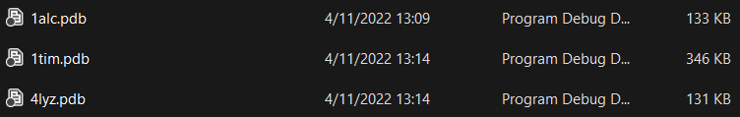

1. We open PyMol and open 1TIM file in it and we get a cartoon view of the protein.

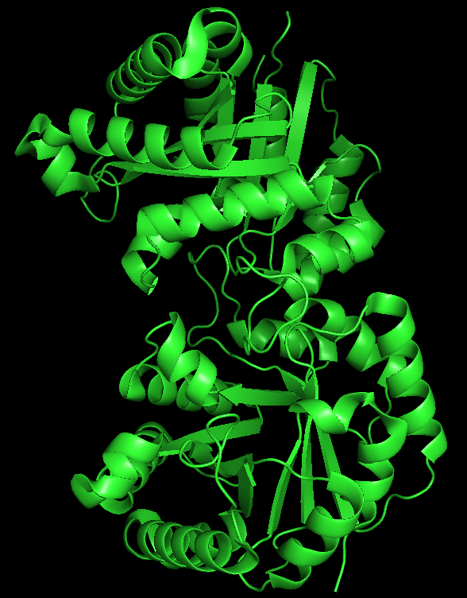

1. We click the “C” icon on the right side panel and we change the color by chain and click okay and we get two colored protein molecule which means that there are two chains in the protein.

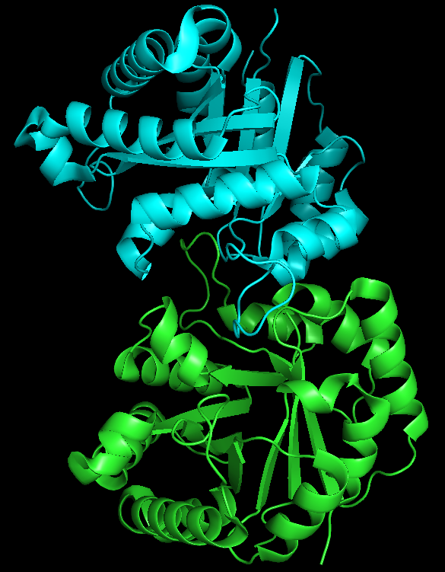

1. We select one of the chains and right click on it, click chain and click hide chain and we get only one chain to be visible in the canvas.

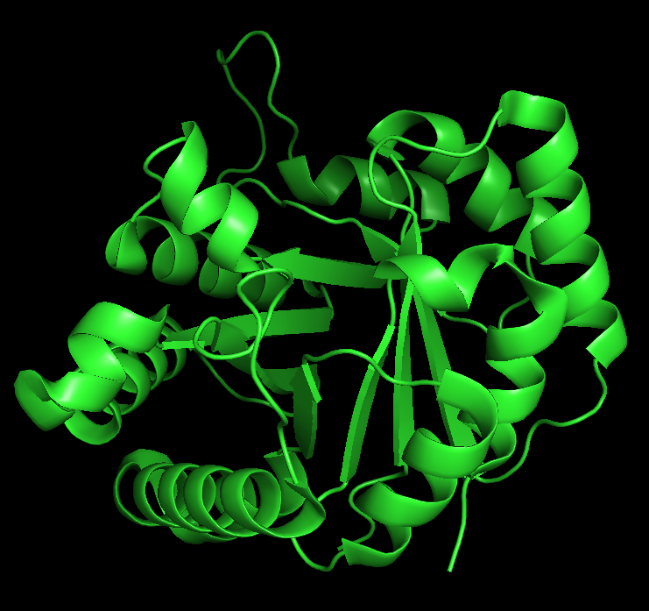

1. We click “C” and click by ss (secondary structure) and click our desired palette and we get the coloring based on the secondary structure. I took Red for alpha helix, yellow for beta sheets and green for loops.

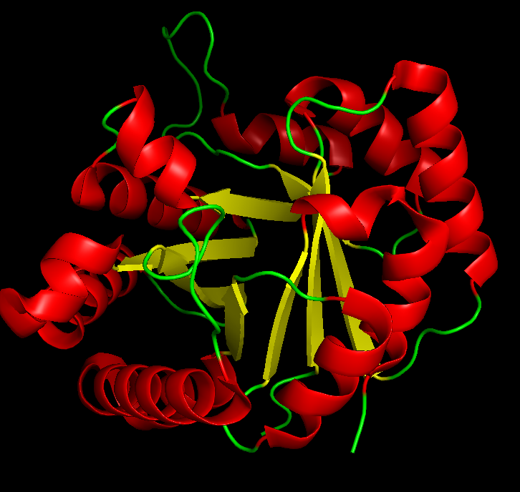

1. We click action, zoom and orient and rotate it to our desired angle.

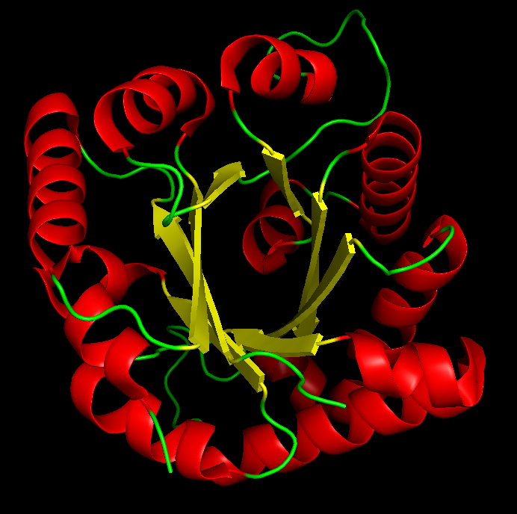

1. Go to display, click sequence to show the sequence. Right not it is color coded by the secondary structure.

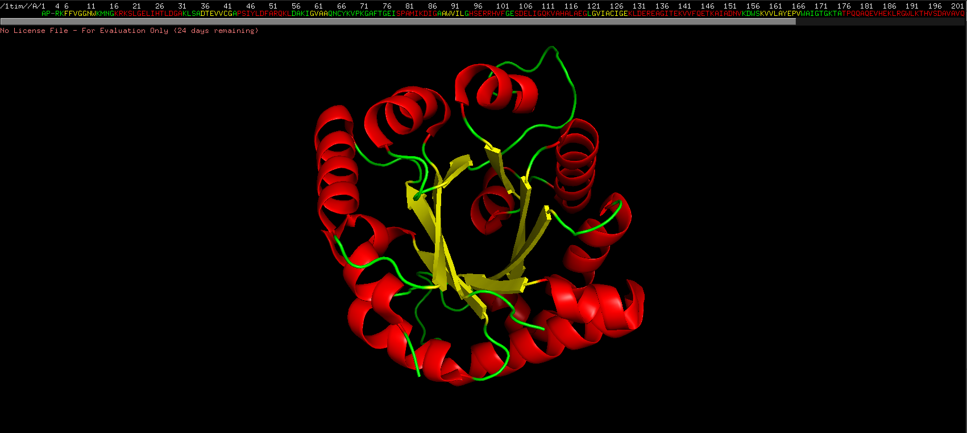

1. In the sequence, we select the residues from 21 to 26 and we get the residues selected.

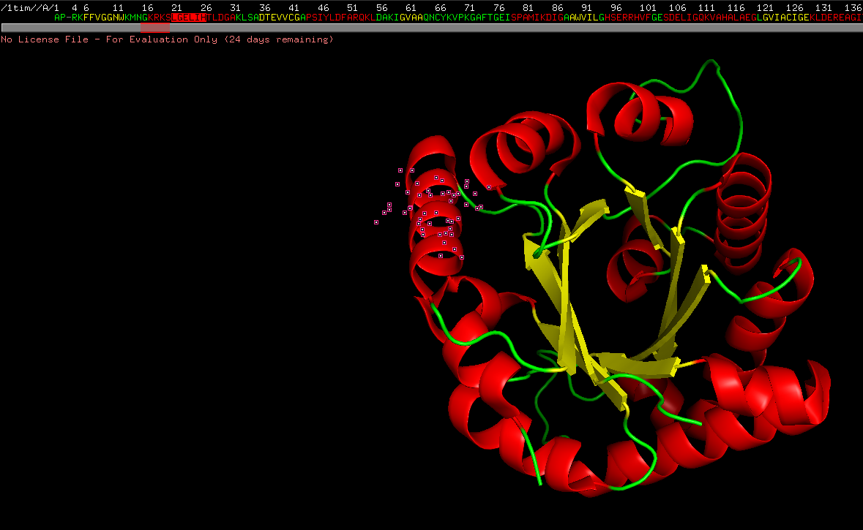

1. We hide the cartoon diagrams by clicking “H” button and click hide cartoon.

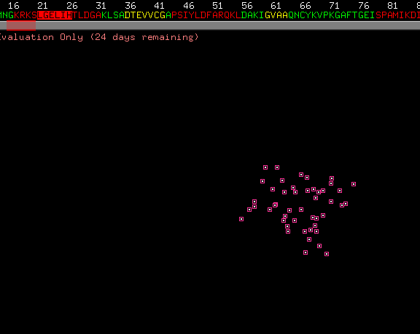

1. We color the residues based on different residues

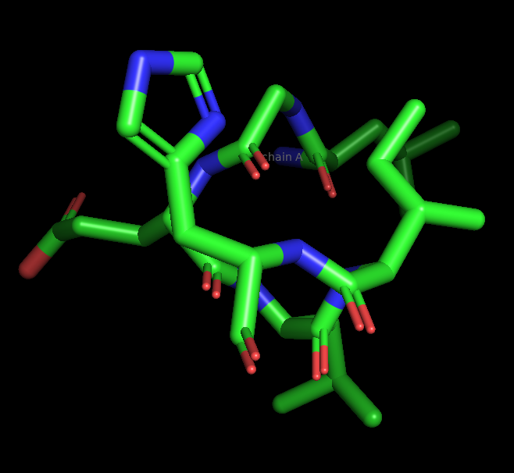

1. For identifying the salt bridges, we click on Action -> Find -> polar contacts and we get four polar contacts which are the salt bridges. Three of them is from nitrogen to oxygen and one of them are from nitrogen to nitrogen.

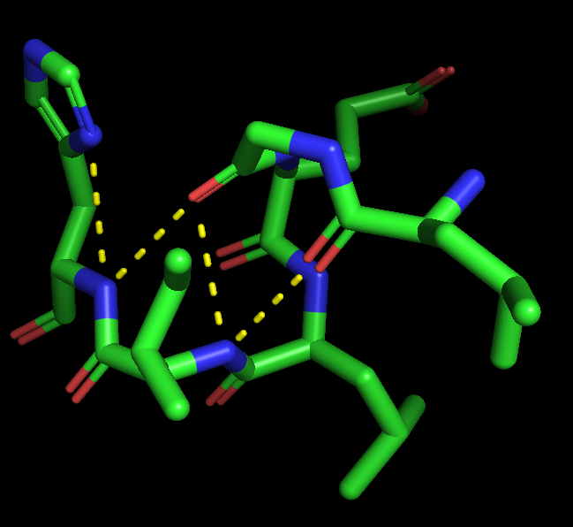

1. We know hydrophobic amino acids, from the selection, we know that the only hydrophobic amino acids are Isoleucine and Leucine and the only hydrophobic bond that’s forming between them is the oxygen of Leucine-21 to carbon of Isoleucine-25

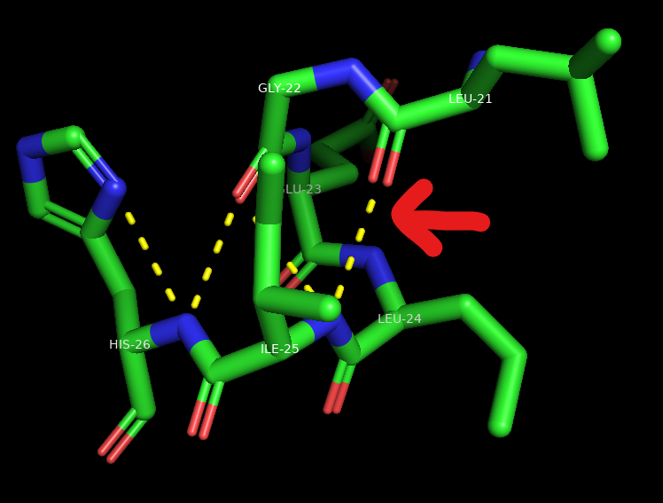

1. We label the residues using atom name and find the Vanderwaal’s radii using the label option -> vdw radii.

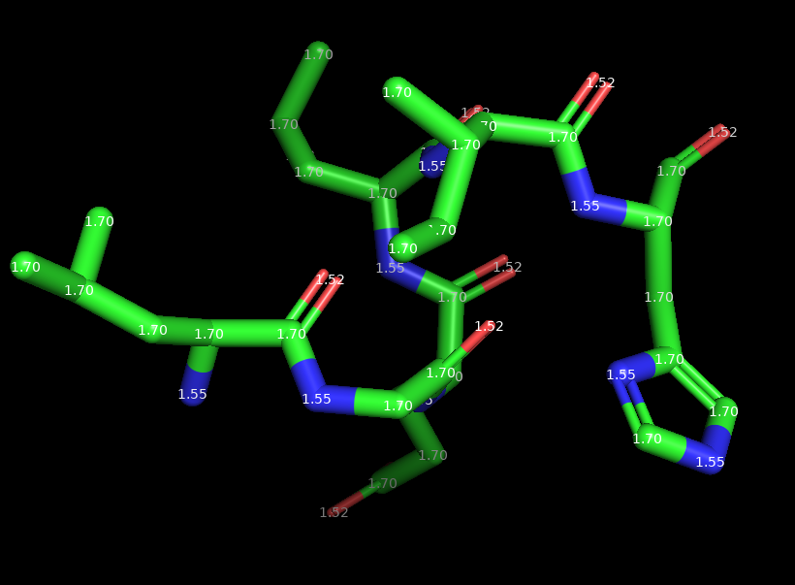

1. We go to wizard, click measurement and measure the distance between CG and CD2. And it came out to be 1.5 angstroms.

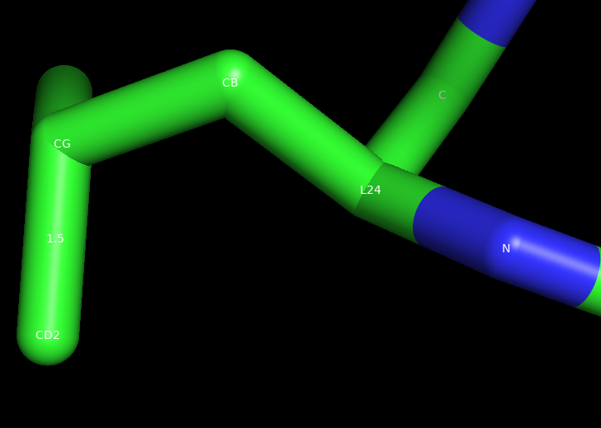

1. We use the wizard, measurement and clik on angle option to measure the angle between CD1, CG and CD2 and we get an angle of 109.9o.

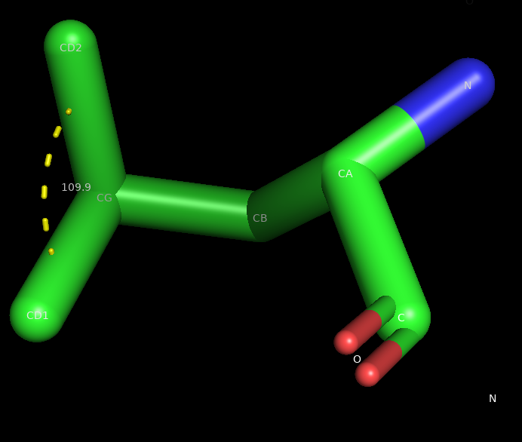

1. Leucine 24 is connected to glutamic acid 23 and isoleucine 25. We find the dihedral angles of these two residues with the leucine 24. We get two of each omega, phi and psi angles.

|  |  |  |  |
| --- | --- | --- | --- |
|  | Phi | Psi | Omega |
| E23-L24  L24-I25 | -41.4  -55.4 | -57  -56.9 | -178.5  -178.5 |

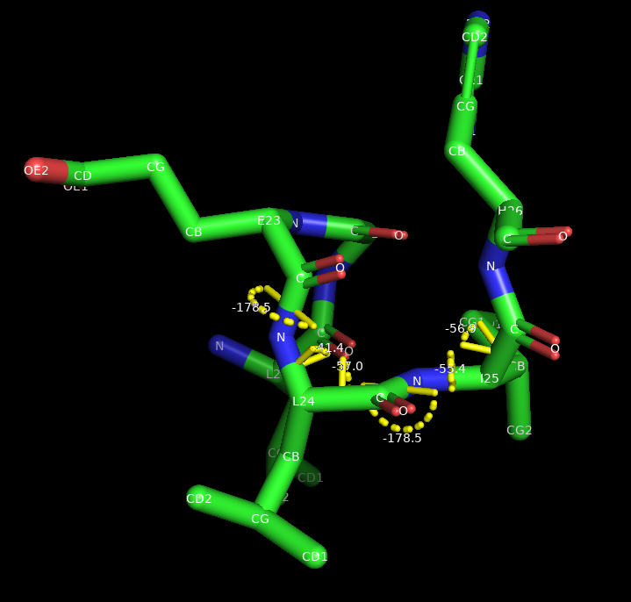

1. We go to display, change background to white.

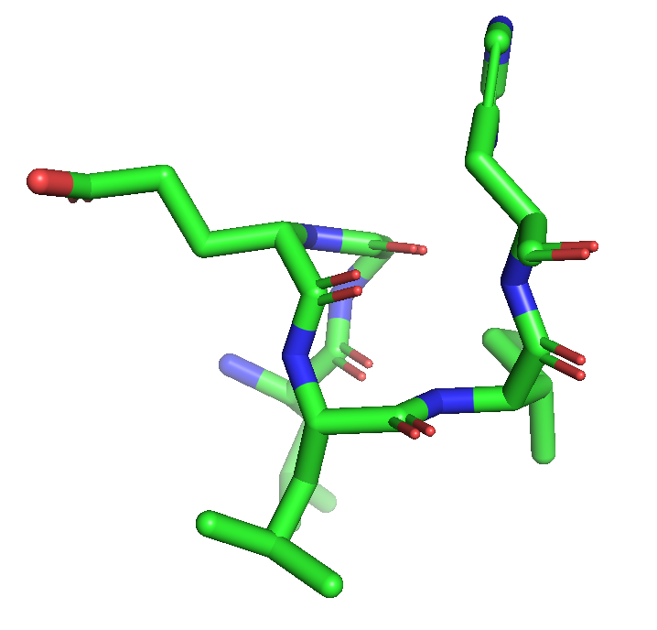

1. We make a high-quality picture using the ray button on the top right.

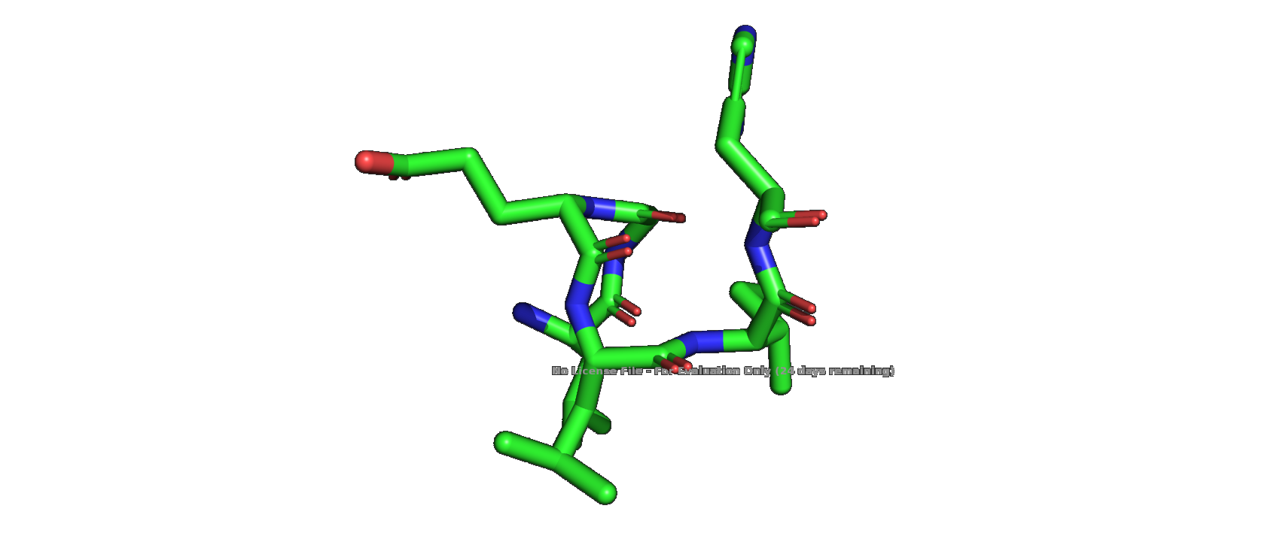

1. We go to color and color it by spectrum.

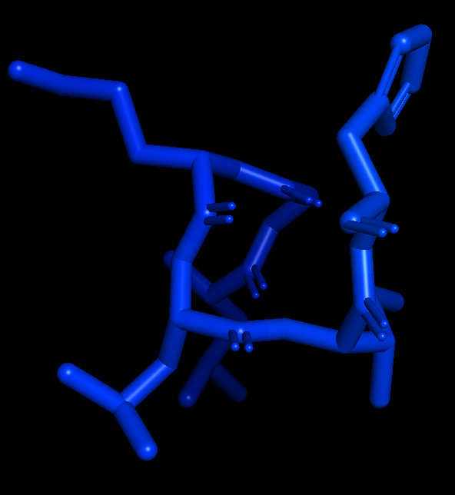

And color it by B-Factor

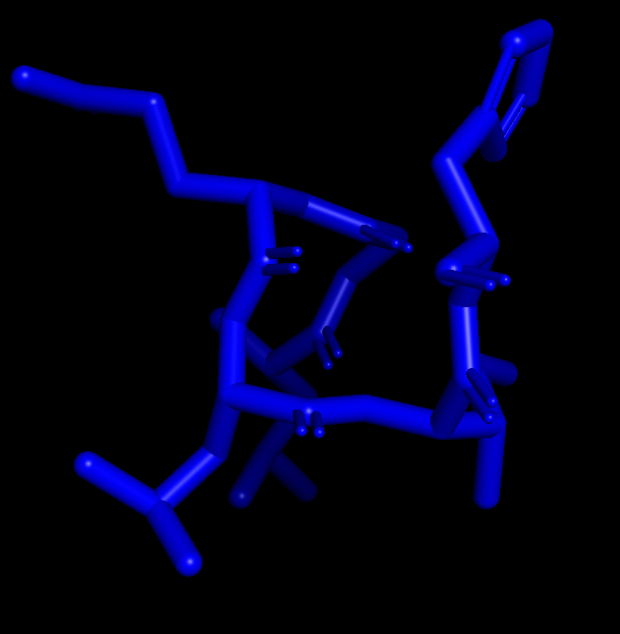

And it seems like there are only one color. So we can say that there are no flexible and rigid regions in this selection. Almost every atom has similar flexibility.

1. We follow the steps given in the question to compute the electrostatic potential and we get he following result.

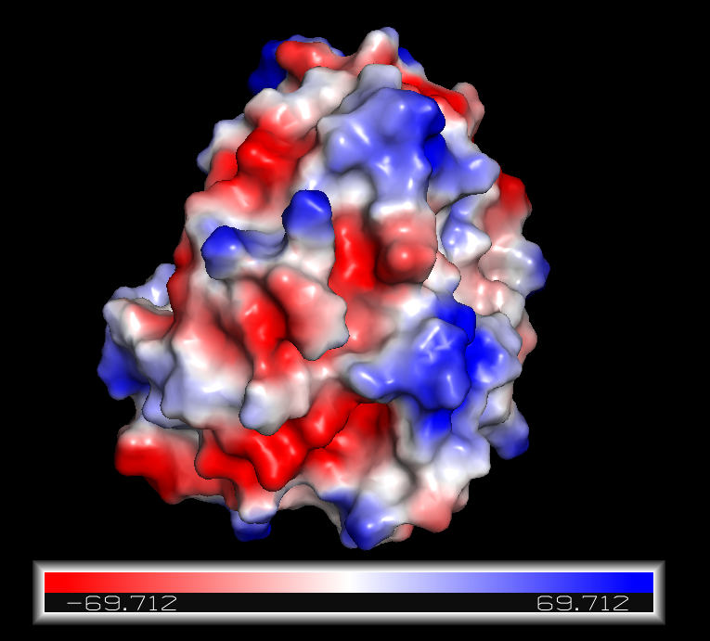

util.sum_formal_charges: -1

util.sum_partial_charges: sum = -1.0000

Util: Calculating electrostatic potential...

SelectorMapCoulomb: Total charge is -1.000 for 3715 points (3715 atoms).

SelectorMapCoulomb: Evaluating local Coulomb potential for grid (shift=10.00)...

1. We go to file, export the image to PNG format.

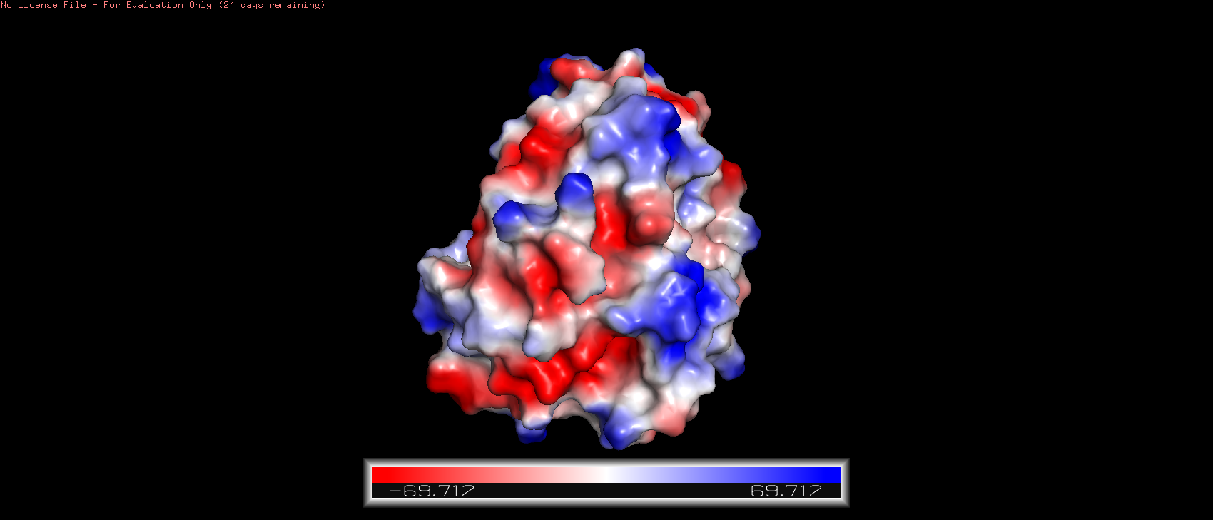

1. We open a new session on PyMol and open both the files 1ALC and 4LYZ into the same canvas.

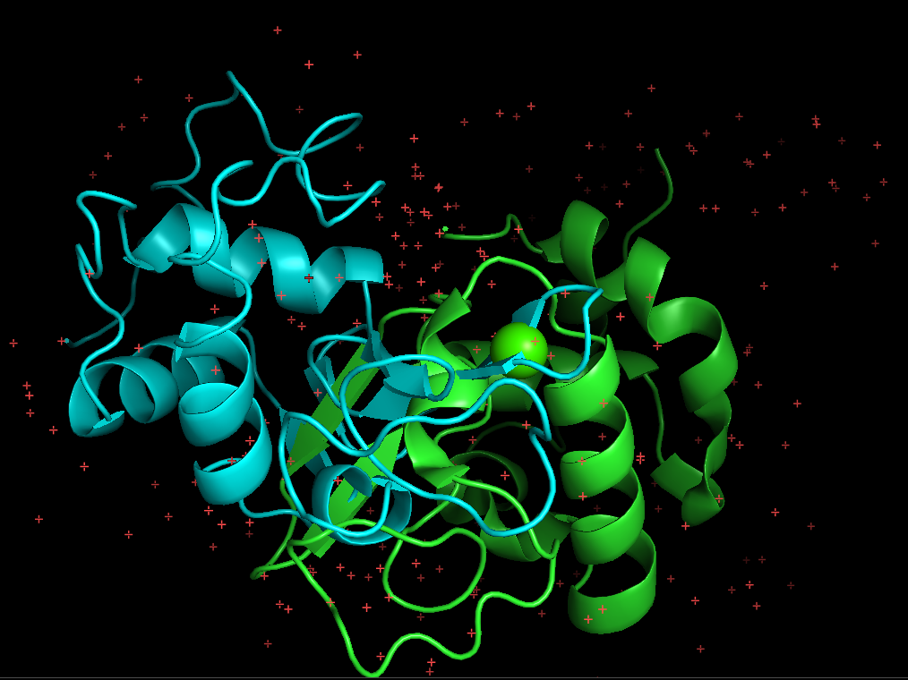

1. We use the command align 1alc, 4lyz to align the two structures.

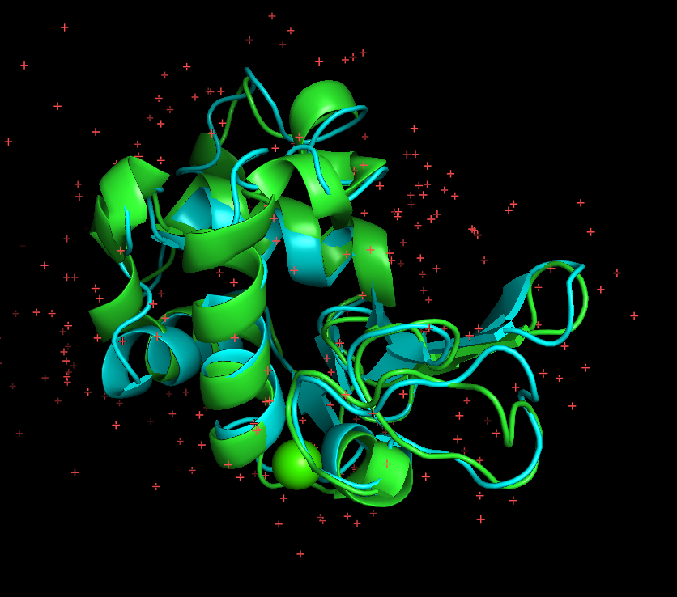

1. When we aligned the two protein molecules, we get the data of RMSD value.

Match: read scoring matrix.  
 Match: assigning 273 x 230 pairwise scores.  
 MatchAlign: aligning residues (273 vs 230)...  
 MatchAlign: score 220.500  
 ExecutiveAlign: 780 atoms aligned.  
 ExecutiveRMS: 35 atoms rejected during cycle 1 (RMSD=1.85).  
 ExecutiveRMS: 50 atoms rejected during cycle 2 (RMSD=1.34).  
 ExecutiveRMS: 22 atoms rejected during cycle 3 (RMSD=1.10).  
 ExecutiveRMS: 18 atoms rejected during cycle 4 (RMSD=1.03).  
 ExecutiveRMS: 6 atoms rejected during cycle 5 (RMSD=0.98).  
 Executive: RMSD =    0.964 (649 to 649 atoms)

So, the final RMSD value if 0.964

1. We save the session into a pse file. (file is attached in the submission)
2. We download a new protein from PDB. I downloaded 3GOK which is a transferase protein in humans.

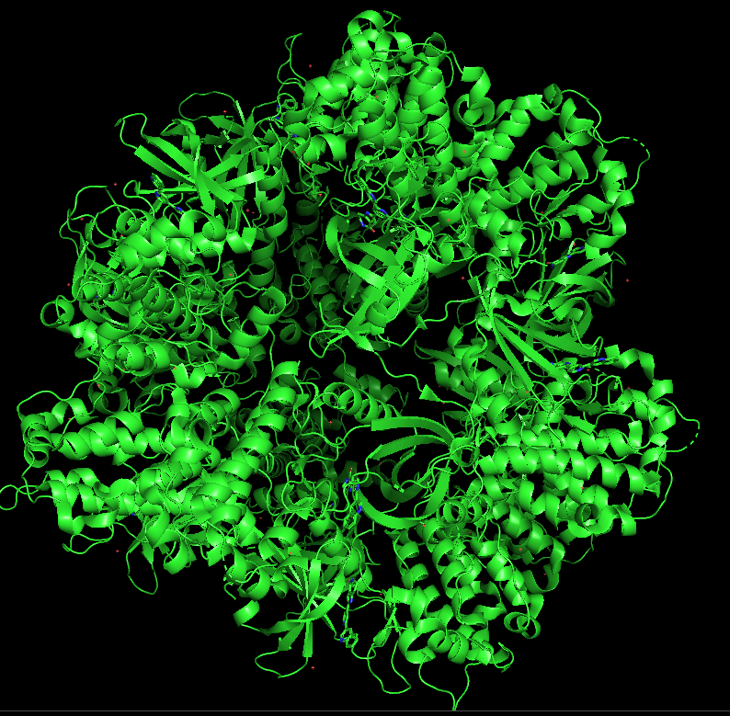

“The protein structure 3GOK”

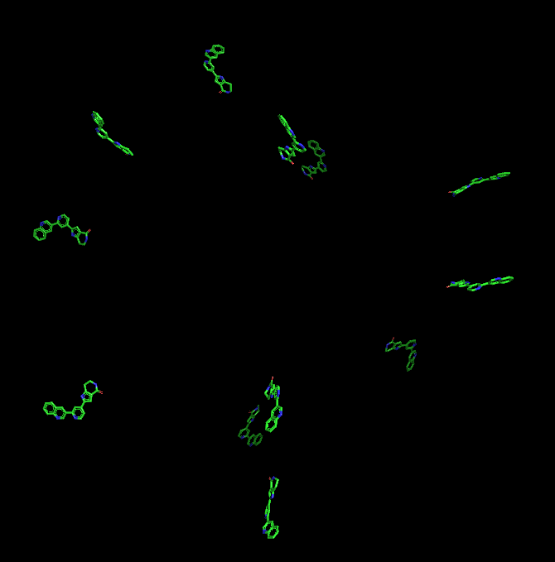

“The ligands of the protein molecule”

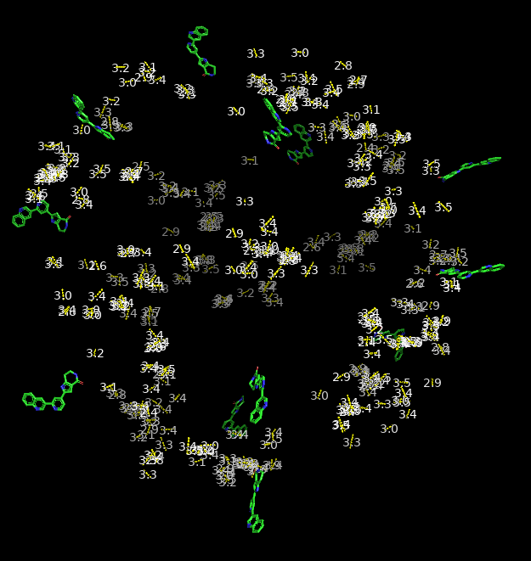

“Residues within 3.5 angstroms”

We selected one of the ligands and we found out that there are two polar interactions.

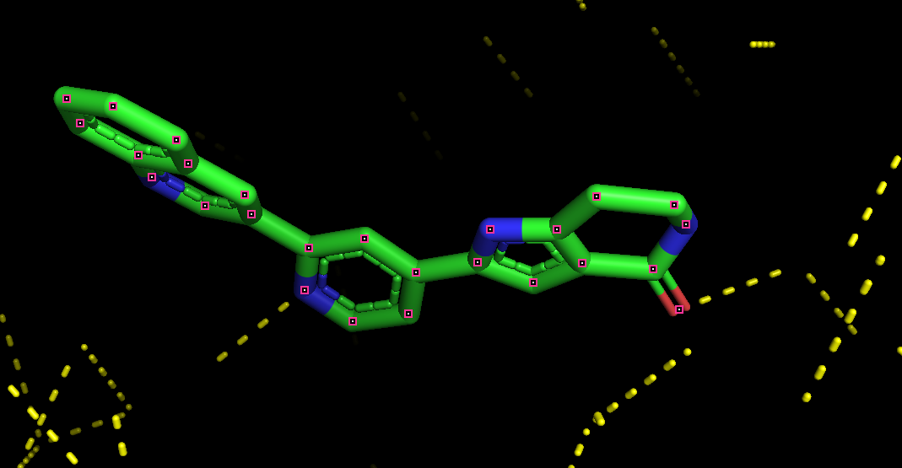

1. Use wizard, mutagenesis and mutate one of the amino acids which is connected with one of the ligands with a polar contact.

We select Lysine 141 to threonine.

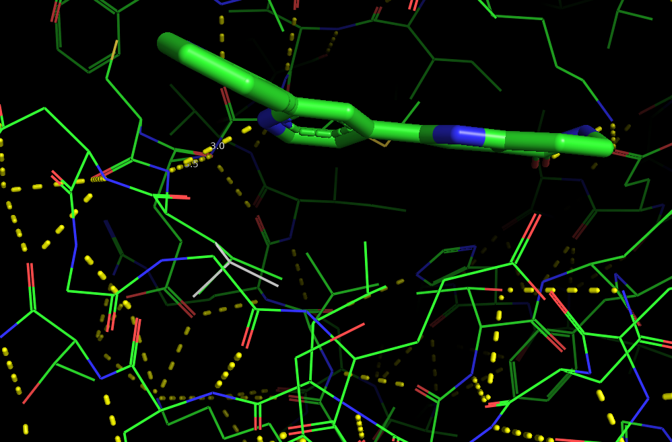

After changing to threonine

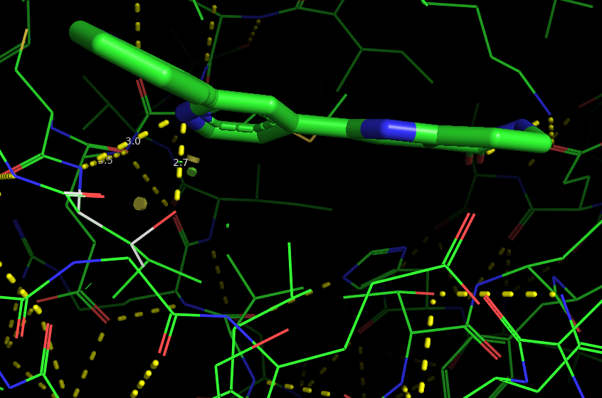

We found that there is an extra 2.7 angstroms polar bond formed between the new mutated lysine141-threonine residue and ligand molecule.

ExecutiveRMSPairs: RMSD =    0.022 (4 to 4 atoms)  
 Mutagenesis: 2 rotamers loaded.  
 Rotamer 2/2, strain=11.83  
 Rotamer 2/2, strain=11.83

Mutation percentage=41.7%